Sinet Sem

Homework
Operating System(chapter 3 & chapter 4)
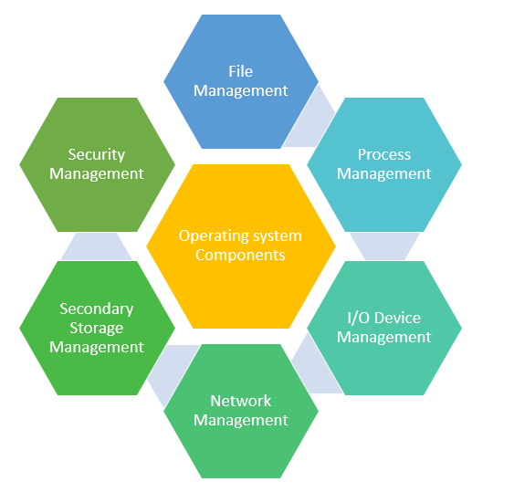

- Setup new Operating system on VirtualBox:

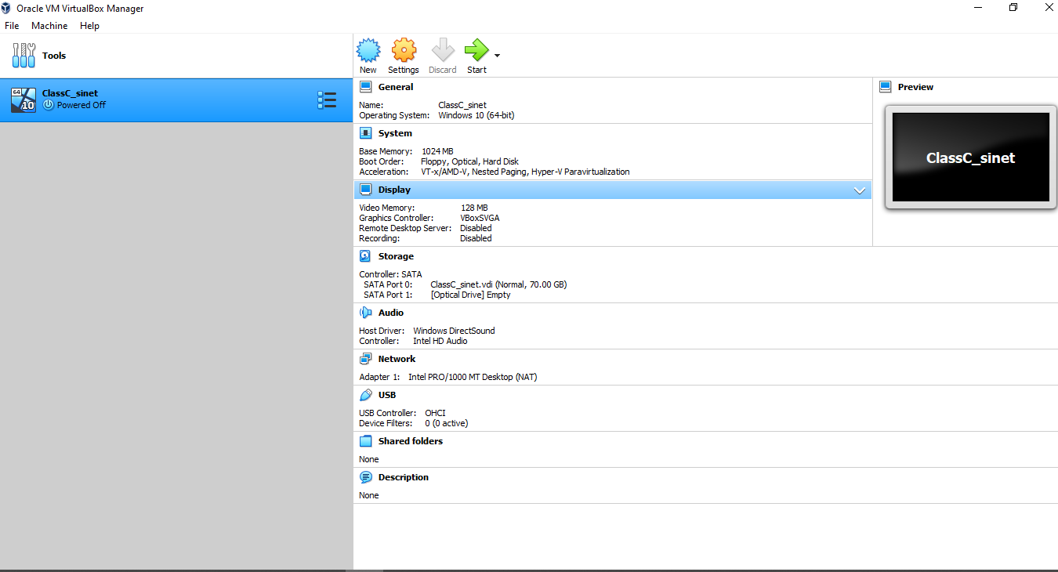

- Login username and password on Window 10:

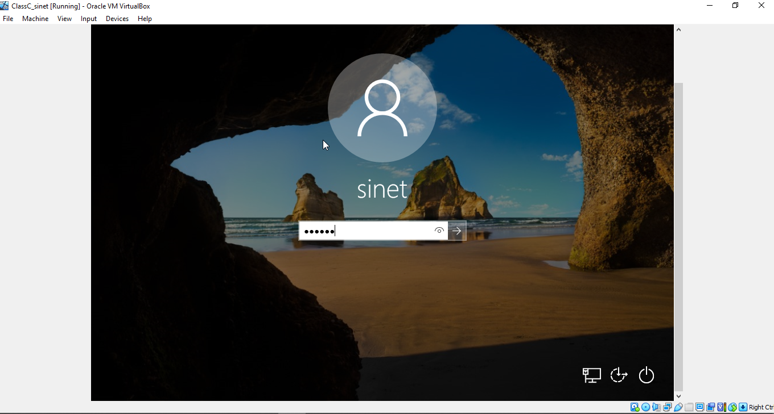

- Divide Partition (During setup os):

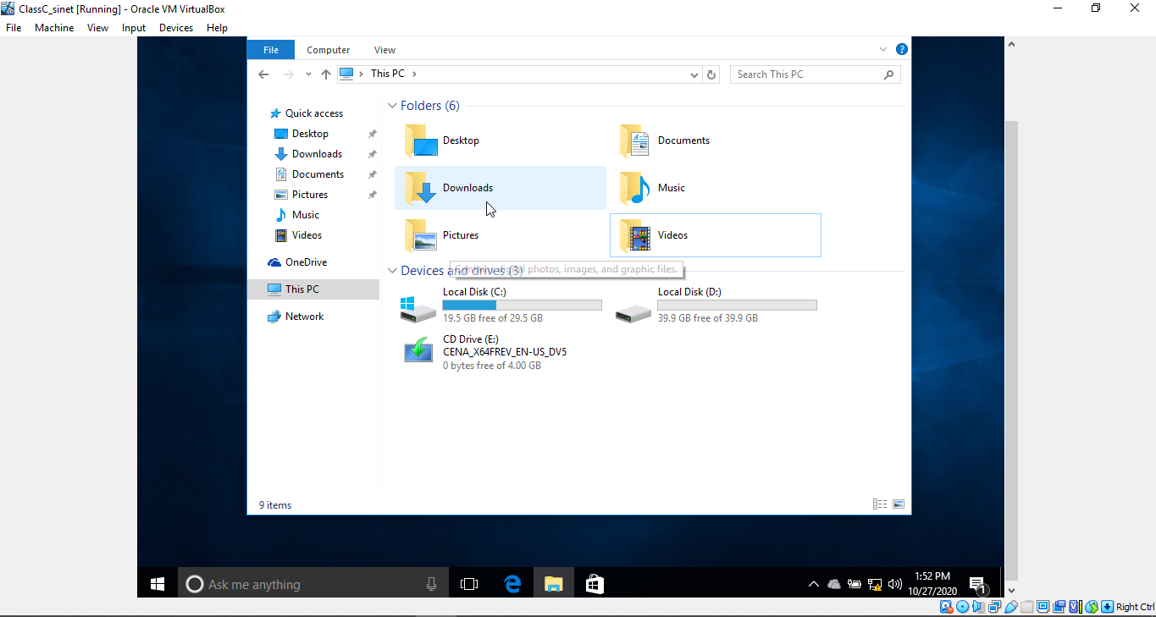

- Add new Hard disk on Virtual machine by using Disk management:

